**Guardians OF Galaxy and Spiderman far from home**

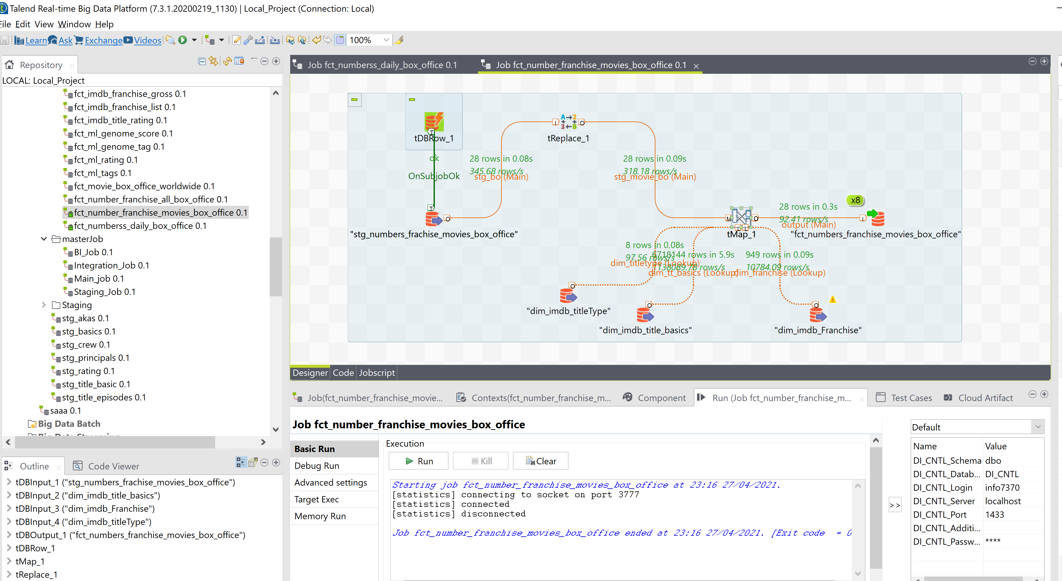

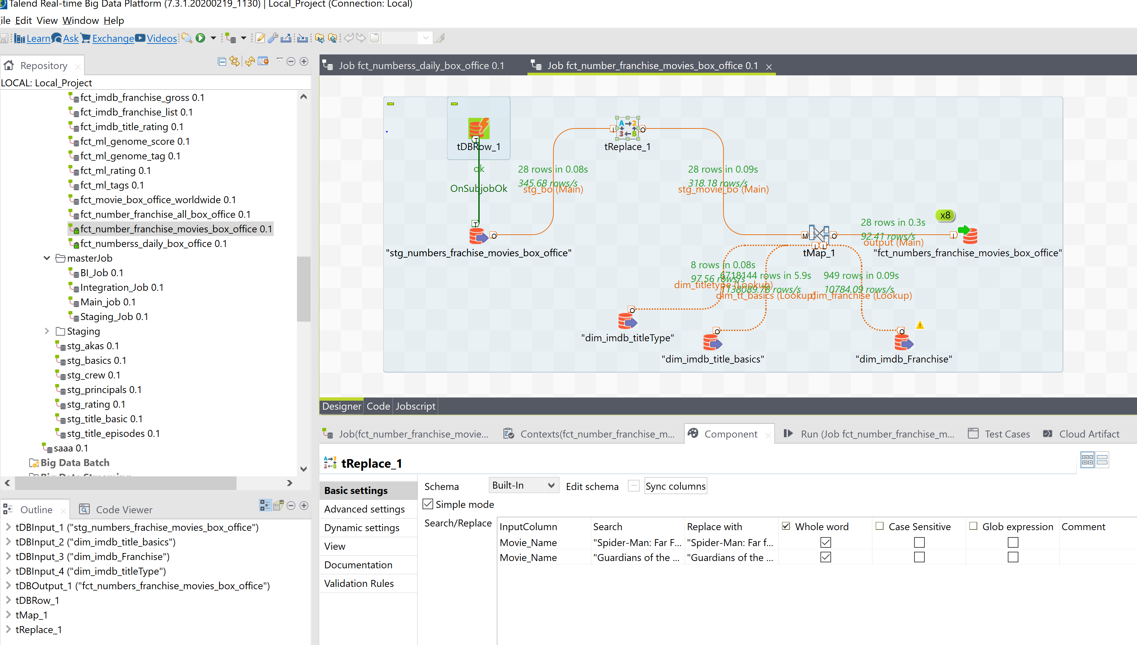

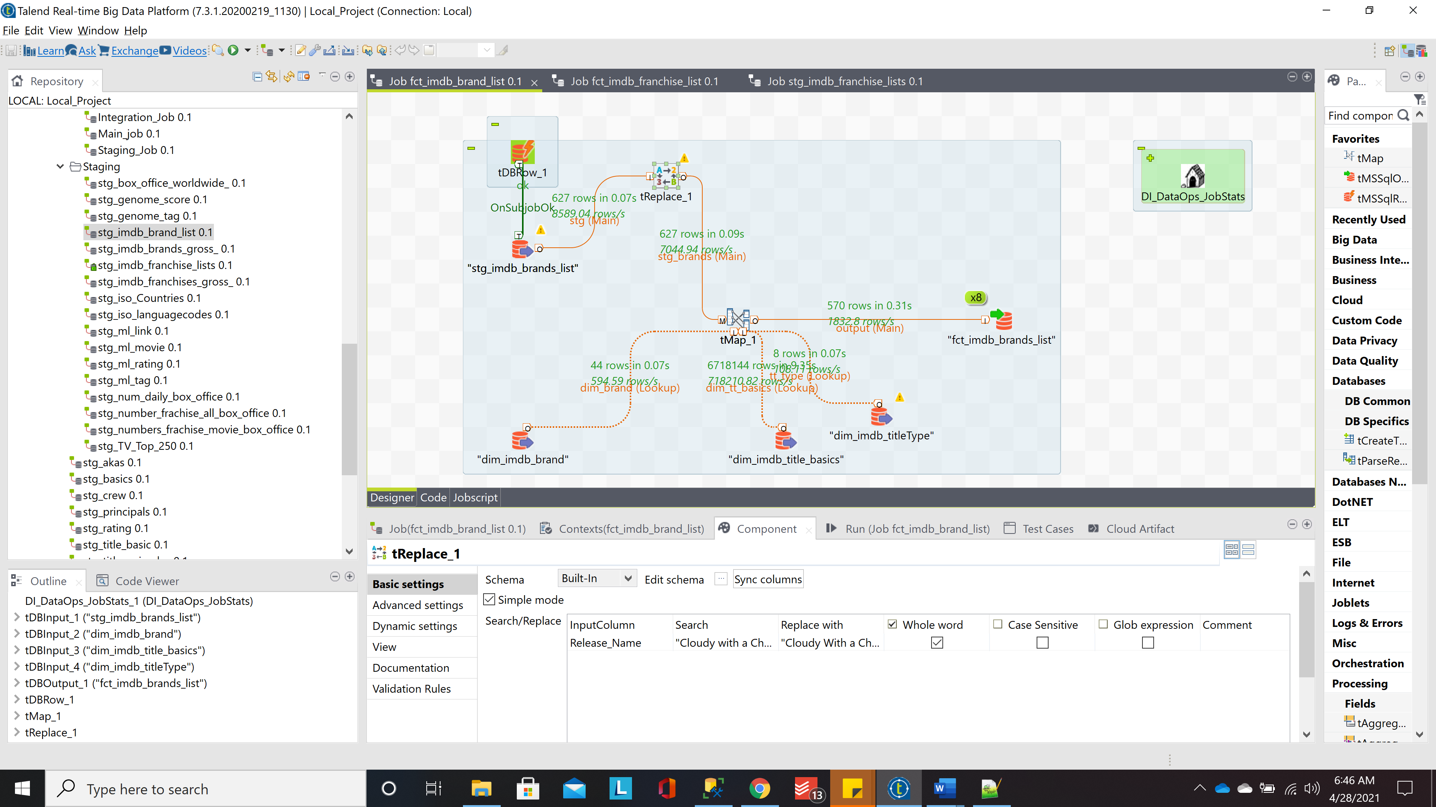

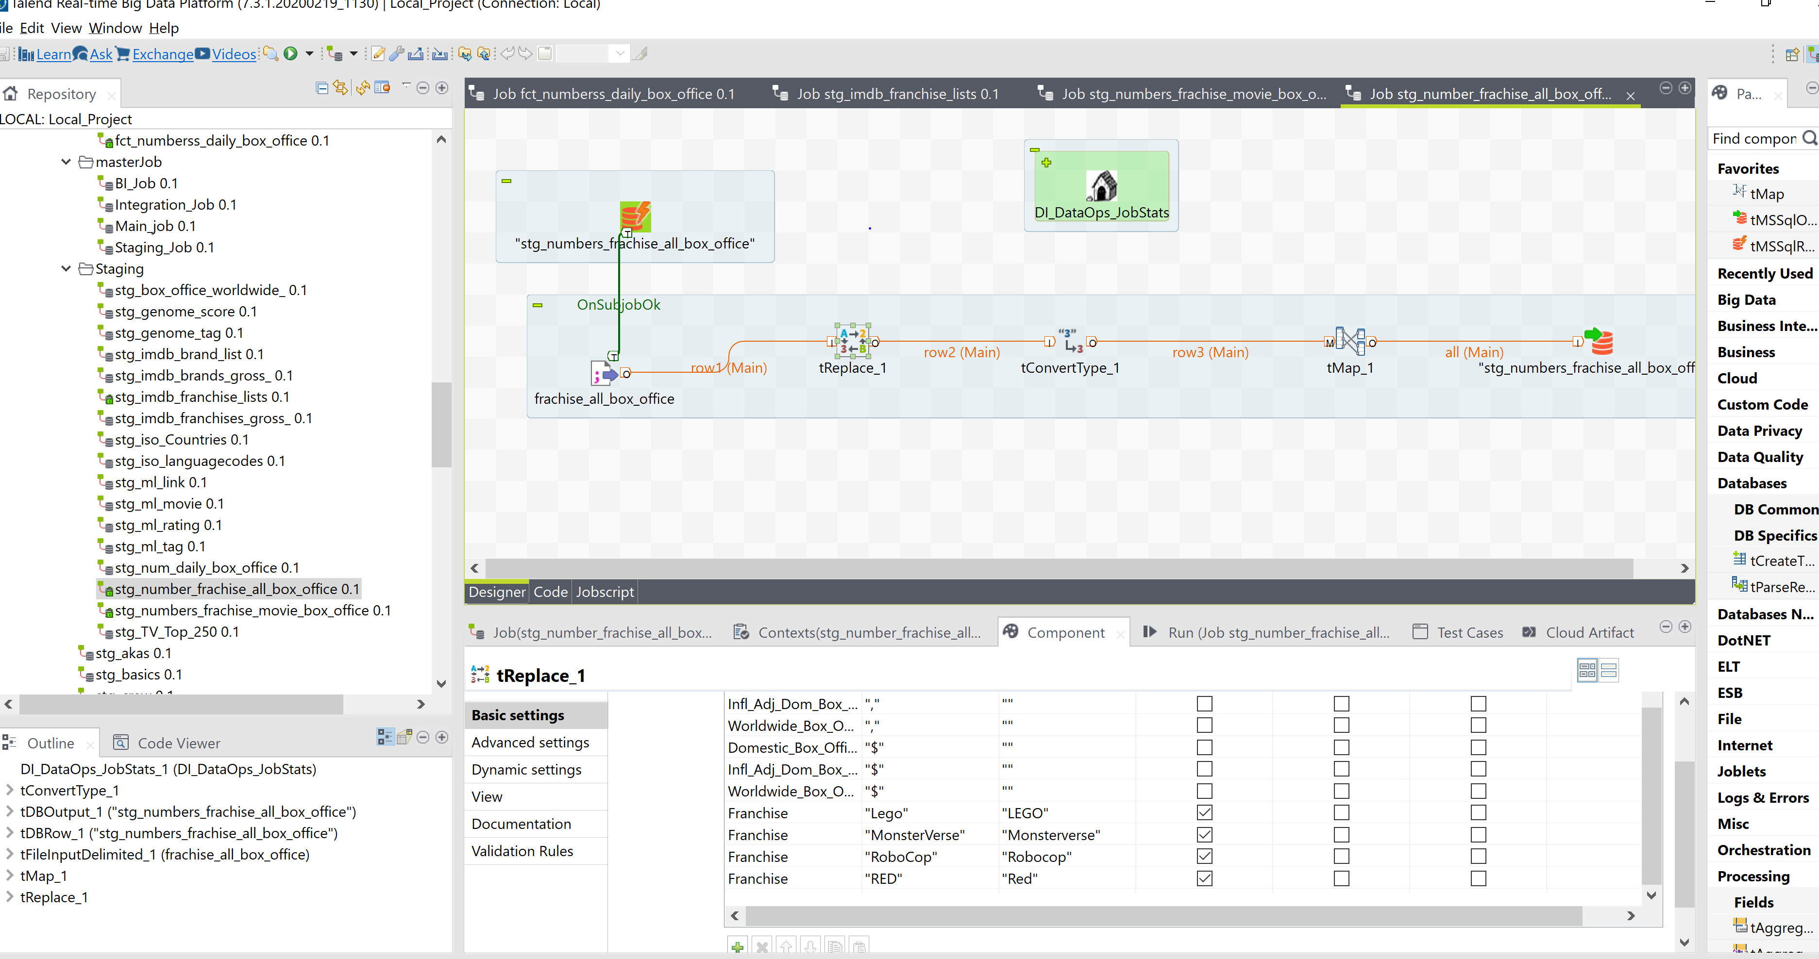

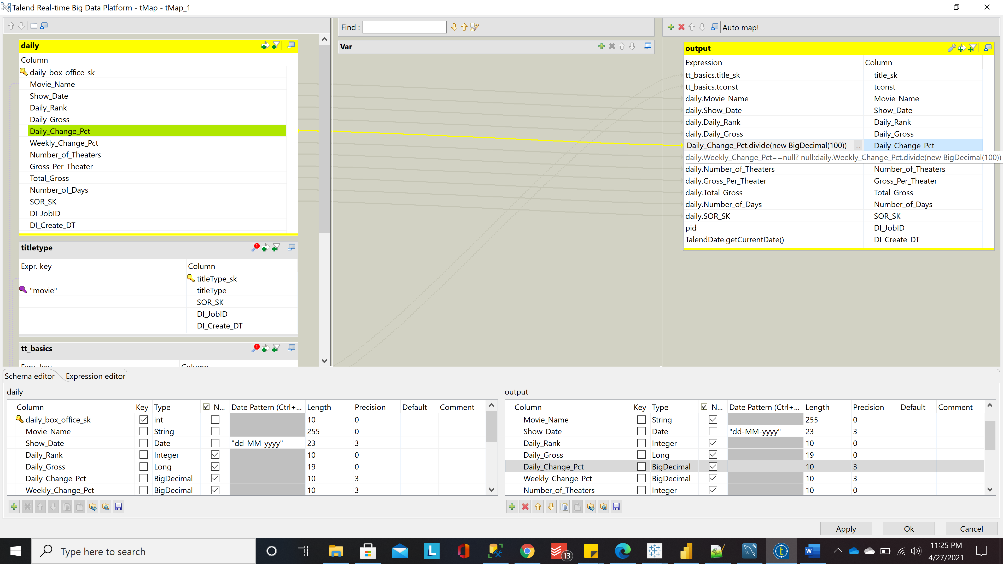

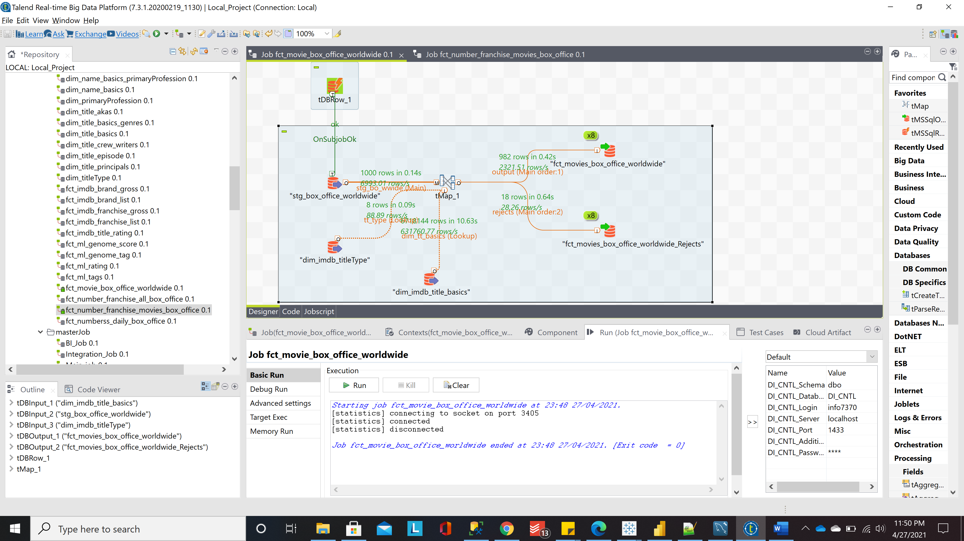

UNCLEANSED RECORDS

Total 28 movies after removing re-release and special edition movies. These could not be mapped due to fault in data either in year, title or name. Ideal count of movies should have been 587 but for us it is 570

Total records screenshot with 587 records

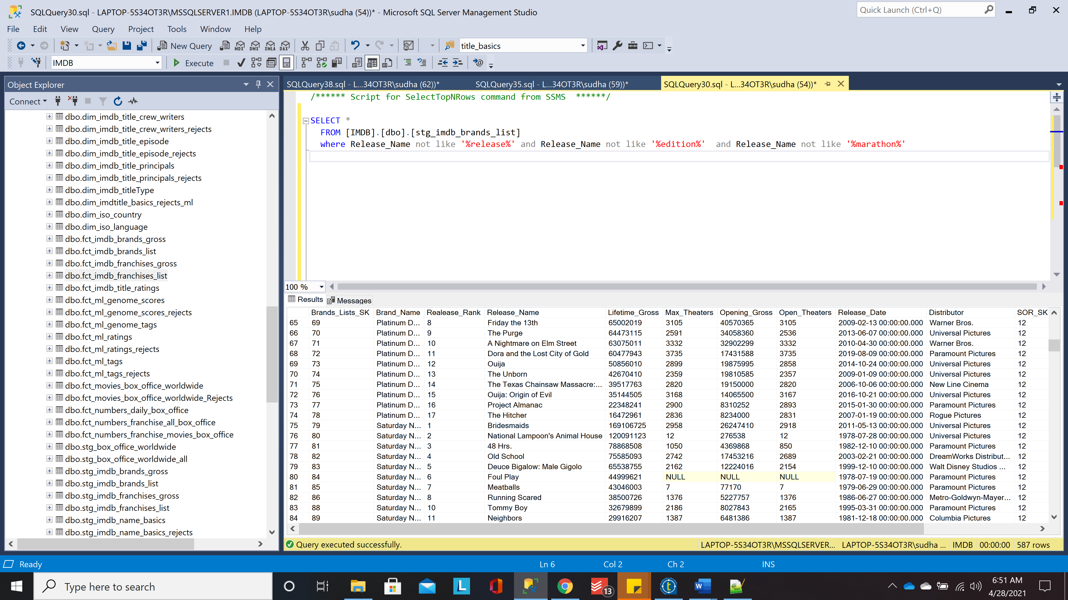

But our fetched records

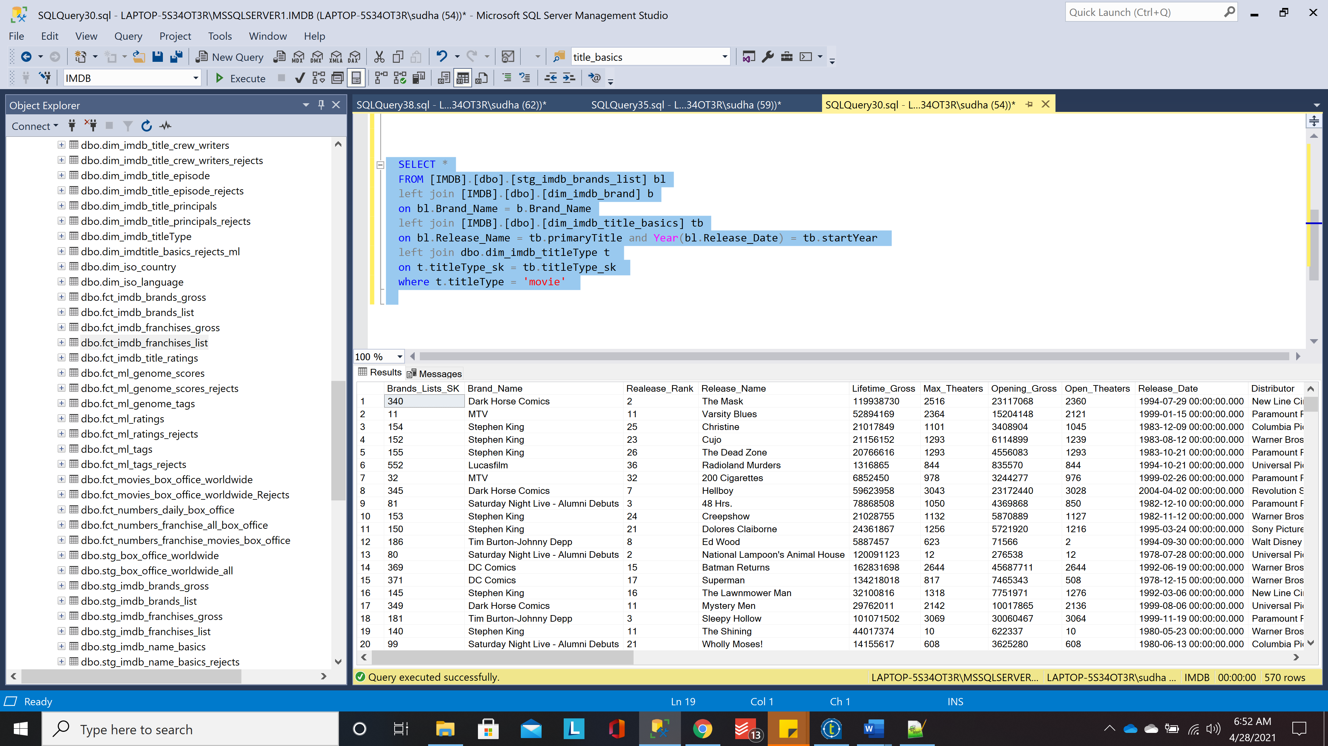

One Typical Example

